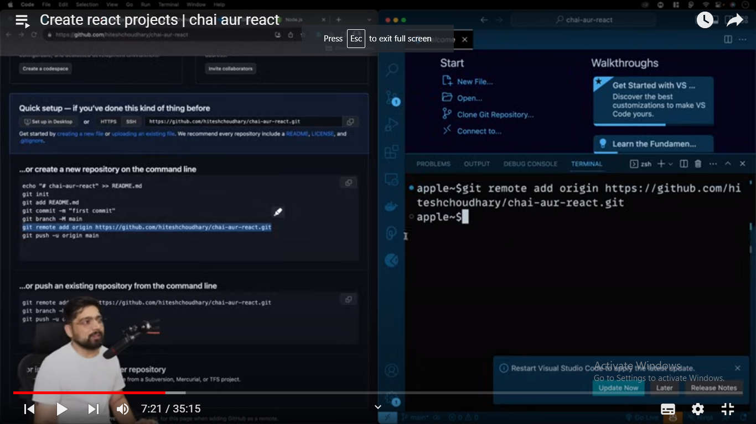

git push –u origin main -🡪 is for renaming the branch

// go to the react.dev website for the documentation

// we have react frameworks like next js , Gatsby, remix 🡪 for without frameworks use vite or parcel they are the bundlers( they are the bundles of files of js that are stored in one location)

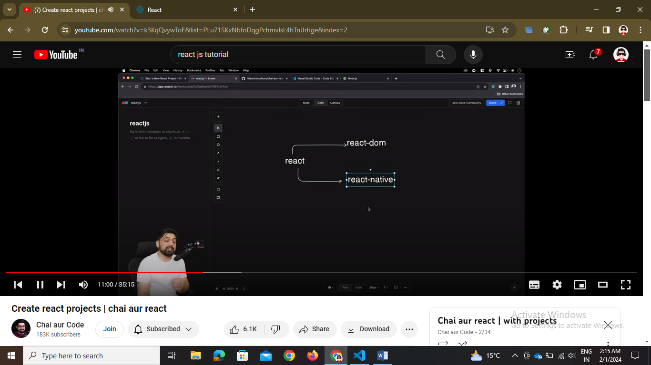

// react is foundational 🡪 react dom for web apps and react native for the mobile apps

// whereas three js is for animations

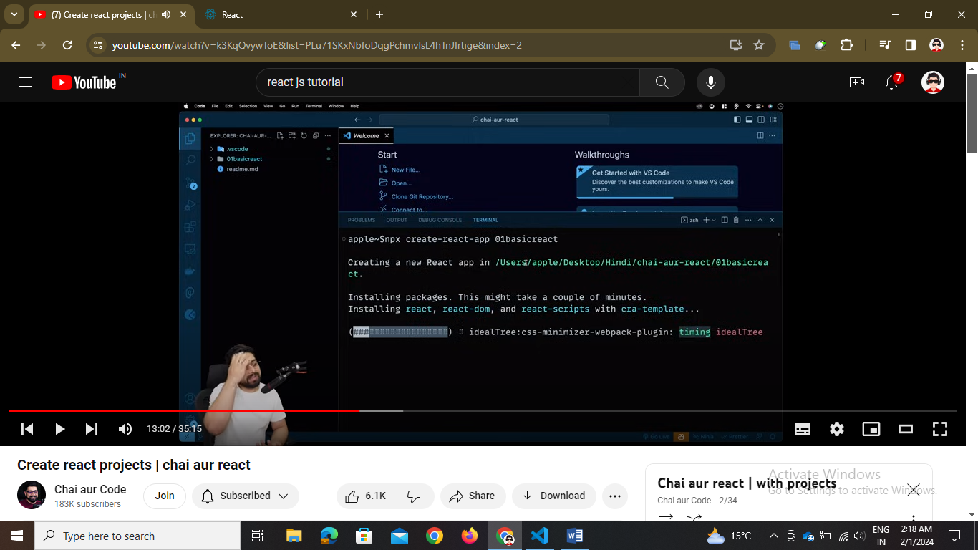

// traditional step 🡪 npx create-react-app wher npx is node package executer

// jest is for testing library

// scripts mai start is for localhost/ development then build is production phase when the browser interacts in html, css, js

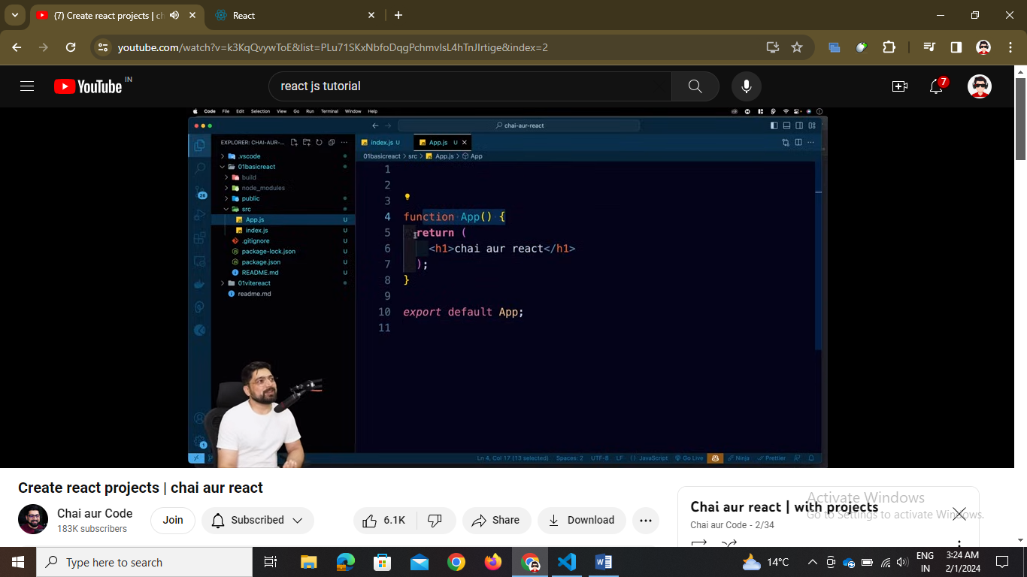

// you can do npm run start or npm start but use run …

// when we use npm run build -🡪 it will create a build folder comprise of html , css , js files

// so as this way is time consuming so we do npm create vite@latest



// folder structure in create-react-app after modifying

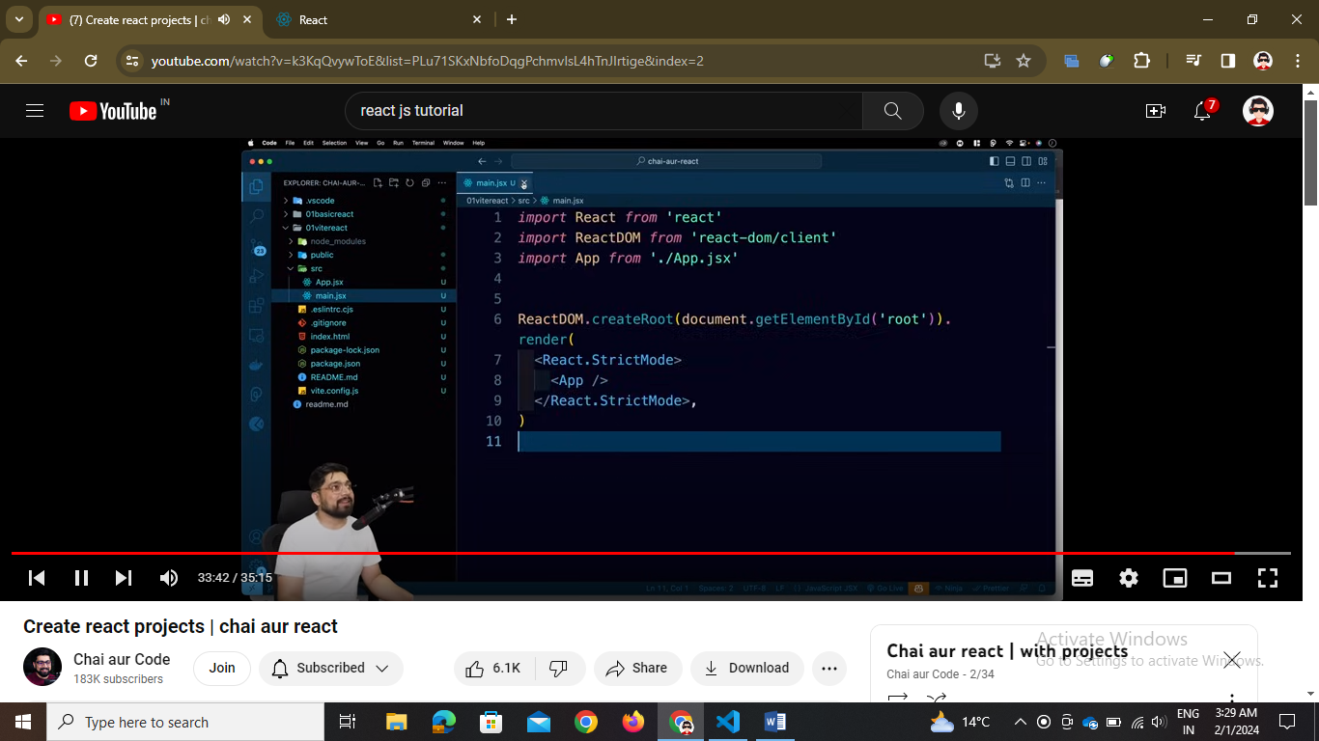

/this is vite folder structure -🡪 for running the dev or prod phase go to the package.json and see command